SCHOOL OF COMPUTER SCIENCE AND ARTIFICIAL INTELLIGENCE |  |  |  |  | DEPARTMENT OF COMPUTER SCIENCE ENGINEERING
Program Name: B. Tech |  |  |  | Assignment Type: Lab |  |  | Academic Year:2025-2026
Course Coordinator Name |  |  |  | Venkataramana Veeramsetty
Instructor(s) Name
  Dr. V. Venkataramana (Co-ordinator)
  Dr. T. Sampath Kumar
  Dr. Pramoda Patro
  Dr. Brij Kishor Tiwari
  Dr.J.Ravichander
  Dr. Mohammand Ali Shaik
  Dr. Anirodh Kumar
  Mr. S.Naresh Kumar
  Dr. RAJESH VELPULA
  Mr. Kundhan Kumar
  Ms. Ch.Rajitha
  Mr. M Prakash
  Mr. B.Raju
  Intern 1 (Dharma teja)
  Intern 2 (Sai Prasad)
  Intern 3 (Sowmya)
  NS_2 ( Mounika)
Course Code |  |  | 24CS002PC215 | Course Title |  | AI Assisted Coding
Year/Sem |  |  | II/I | Regulation |  | R24
Date and Day  of Assignment |  |  | Week7 - Thursday | Time(s)
Duration |  |  | 2 Hours | Applicable to  Batches
AssignmentNumber:14.1(Present assignment number)/24(Total number of assignments)
 | Q.No. | Question |  |  |  |  |  | Expected Time  to complete
 | 1 | Lab 14: Web Design Application – AI-Assisted HTML/CSS/JS Generation  Lab Objectives  - Design functional, visually appealing web applications using HTML, CSS, and JavaScript with AI assistance.  - Apply responsive, accessible, and interactive design principles.  - Create practical UI components for real-world web applications.  - Use AI to optimize layout, UX, and performance.  Task 1: Create a Responsive Web Page Layout  Instructions:  - Design a basic web page layout with a header, main content area, and footer using HTML and CSS.  - Use AI to assist in generating responsive CSS for different screen sizes.  - Ensure the layout is clean and visually organized.  Expected Output:  - A responsive web page with:  - Header with navigation links  - Main section with placeholder text/images  - Footer with copyright or contact info  - Layout adapts correctly to desktop, tablet, and mobile screen sizes.  Prompt:  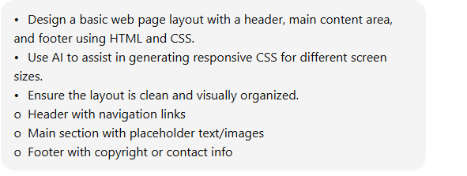  Code:  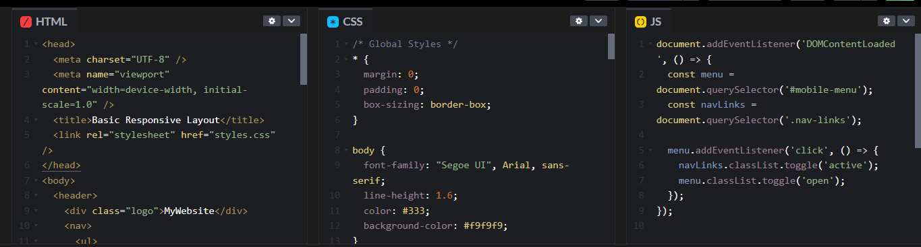  Output:  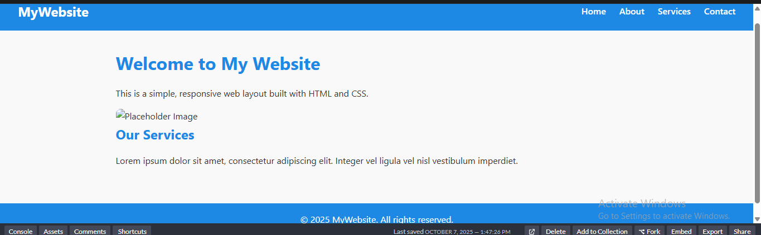  Task 2: Interactive Button with JavaScript  Instructions:  - Create a button on a web page.  - Use AI to generate JavaScript code that displays an alert message when the button is clicked.  - Ensure the code is clean and well-commented.  Expected Output:  - A web page with a button.  - Clicking the button shows a pop-up alert message, e.g., “Button clicked!”.  Prompt:  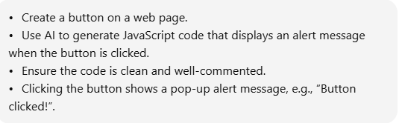  Code:  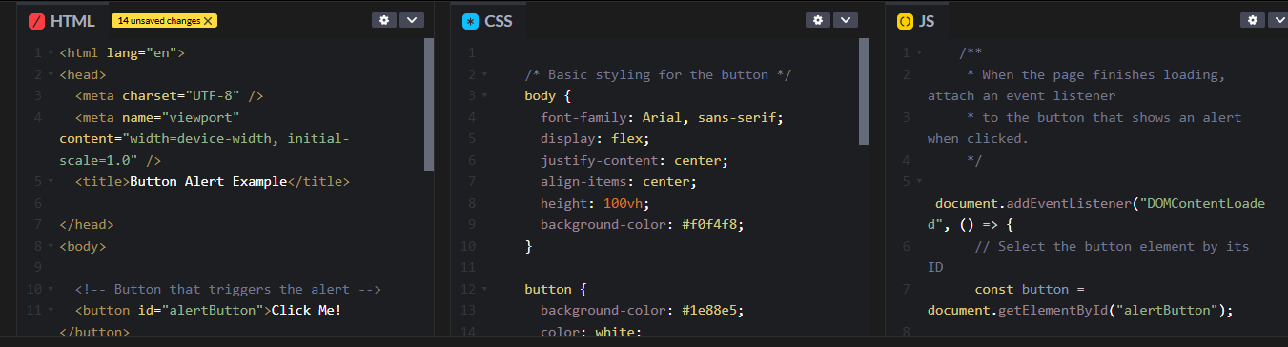  Output:    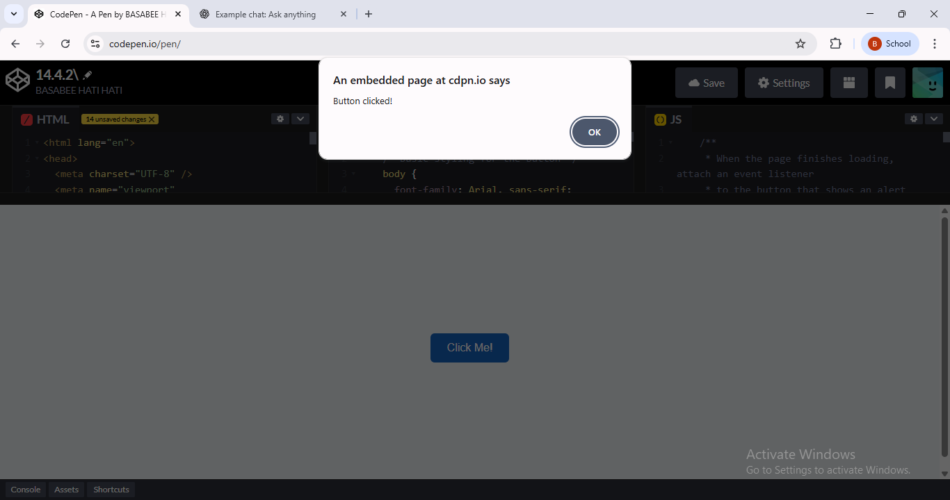  Task 3: Form with Validation  Instructions:  - Design a contact form with fields: Name, Email, Message.  - Use AI to generate JavaScript code for form validation (e.g., non-empty fields, valid email format).  - Add inline error messages if input is invalid.  Expected Output:  - A functional contact form where:  - Submitting with empty fields shows error messages.  - Submitting with valid input displays a “Form submitted successfully” message.  Prompt:  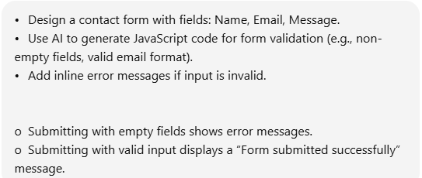  Code:  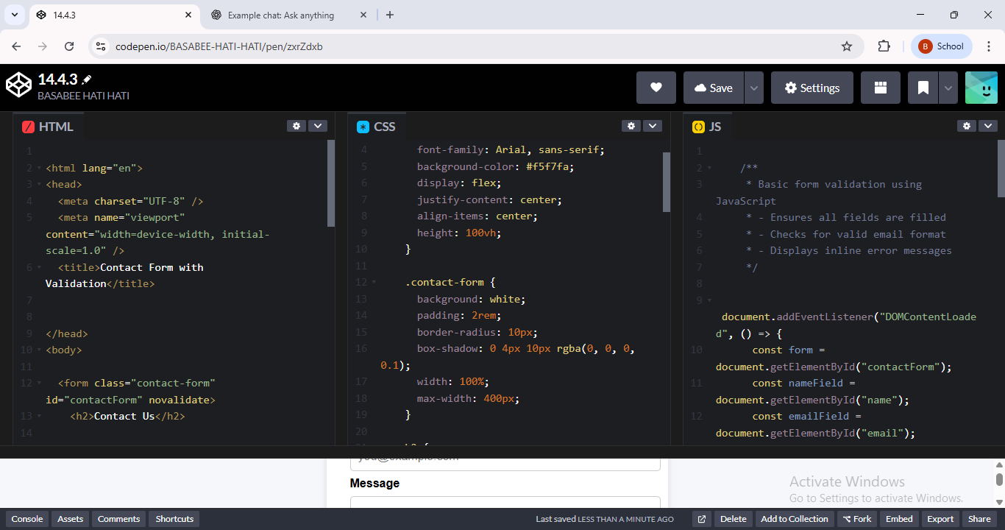  Output:  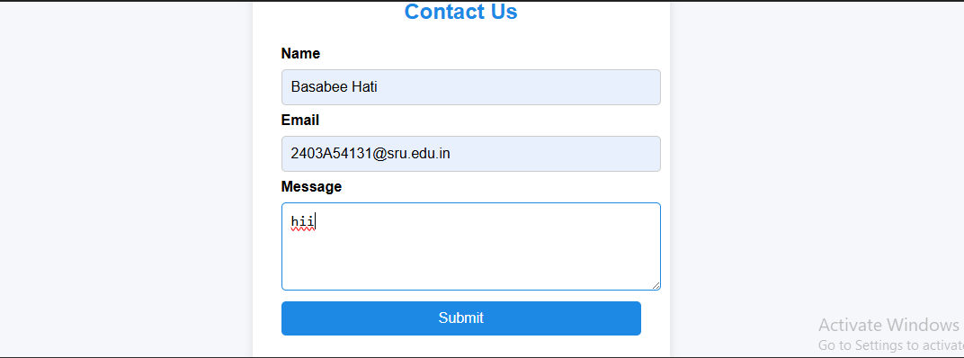  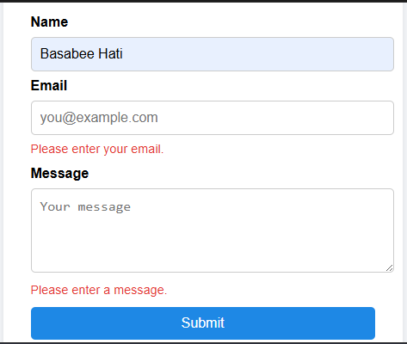  Task 4: Dynamic Content Generation  Instructions:  - Create a list of items (e.g., product names) using HTML.  - Use AI-generated JavaScript to dynamically add or remove items from the list when a button is clicked.  Expected Output:  - A web page with a list and buttons:  - “Add Item” adds a new item to the list dynamically.  - “Remove Item” deletes the last item.  - Updates occur without reloading the page.  PROMT:  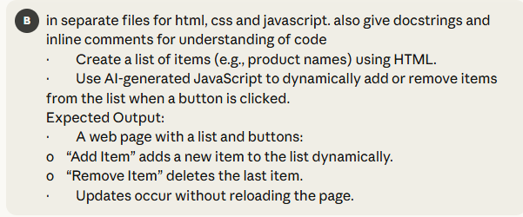  CODE:  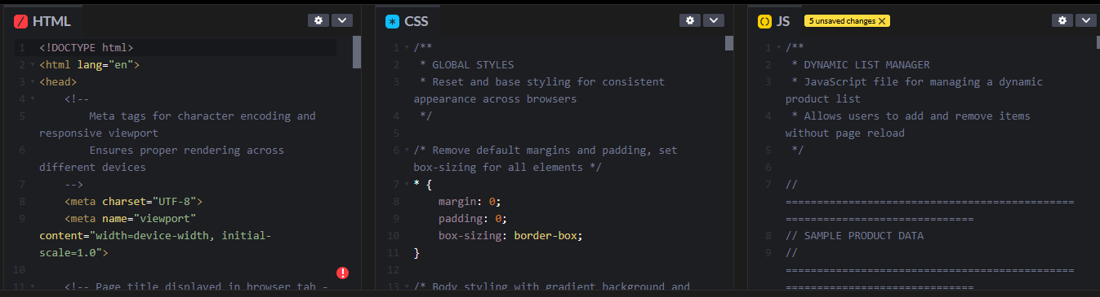  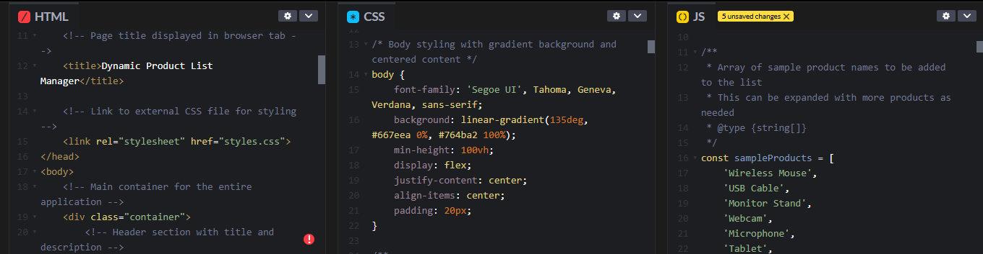  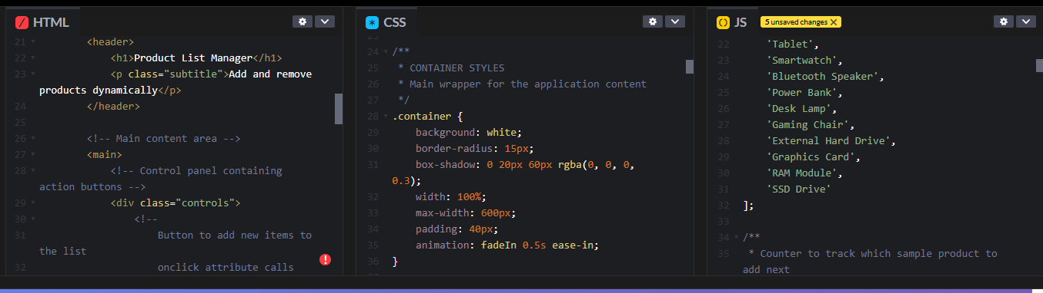  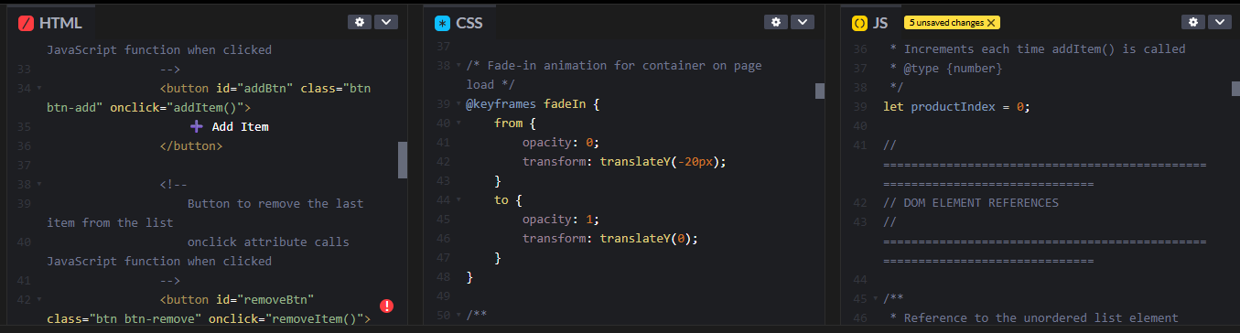  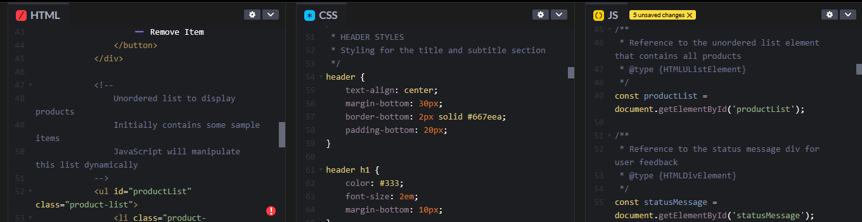  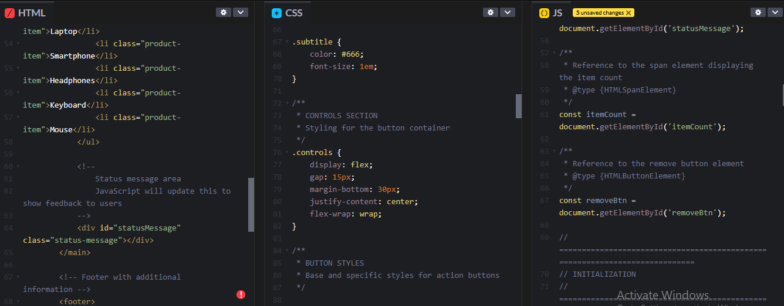  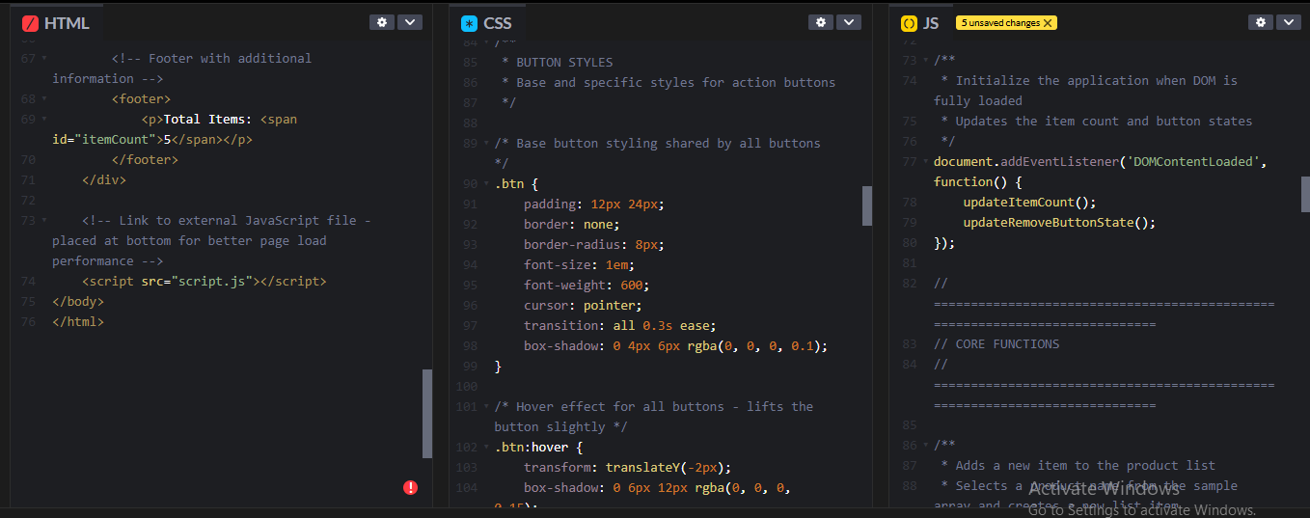  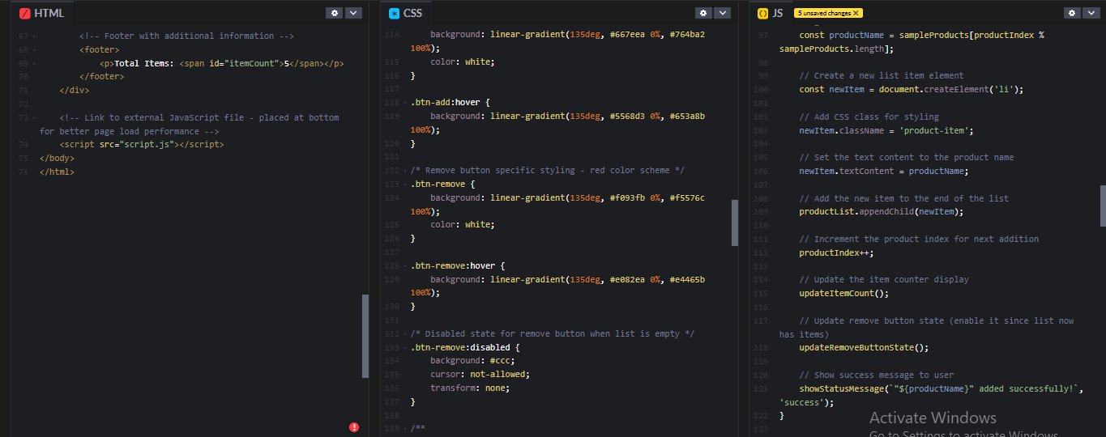  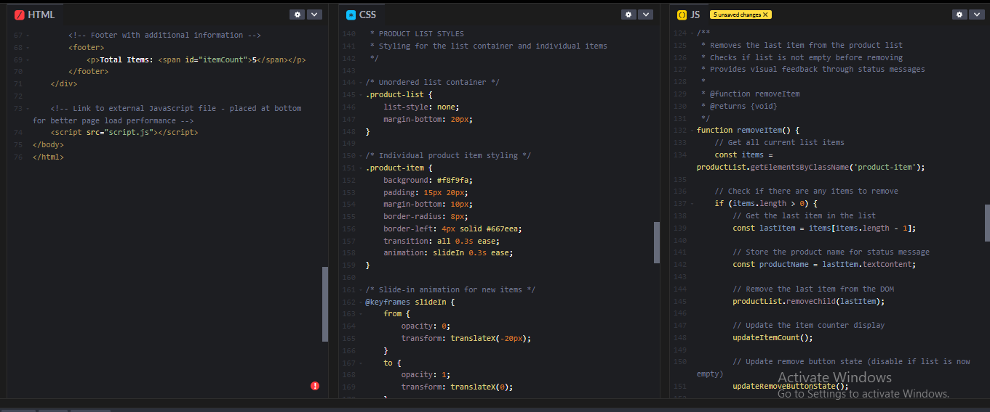  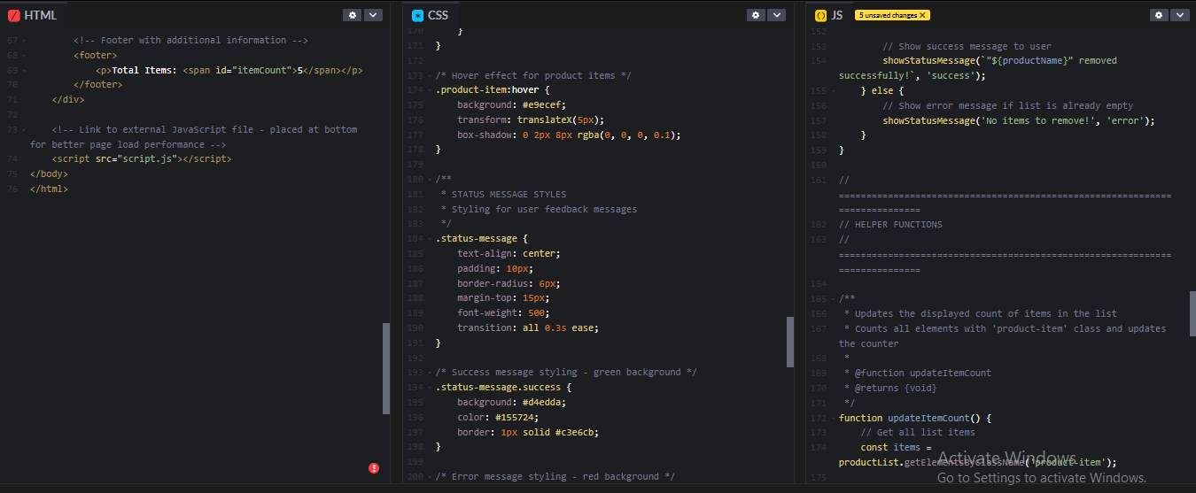  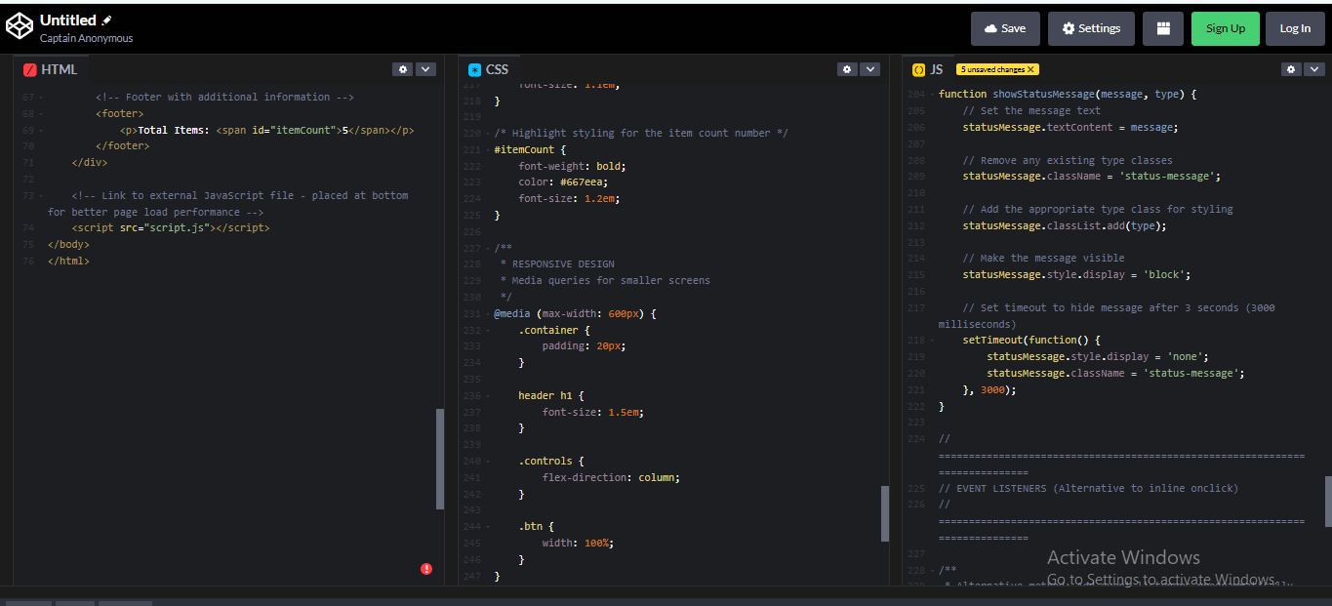  OUTPUT:  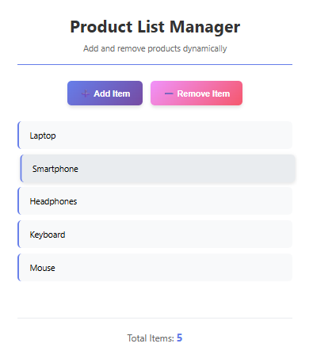  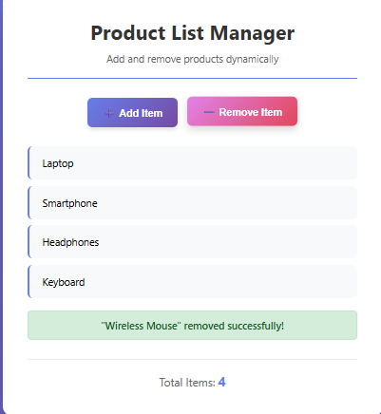 |  |  |  |  |  | Week7 - Thursday
Task 5: Styled Modal Popup
Instructions:
- Use AI to generate a modal popup that opens when a button is clicked.
- Style the modal using CSS with a semi-transparent overlay.
- Include a close button that hides the modal.
Expected Output:
- A web page with a button labeled “Open Modal”.
- Clicking the button displays the modal popup with content.
- Modal can be closed by clicking the “X” button or overlay area.
PROMPT:
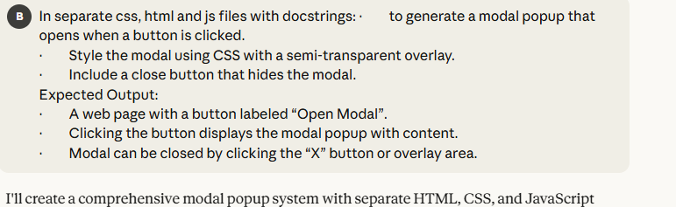
CODE:
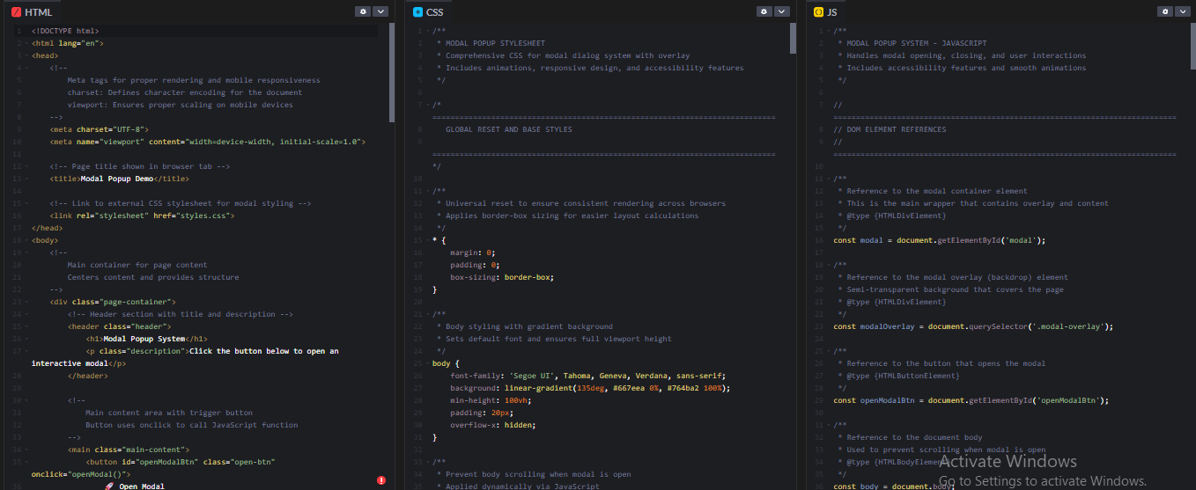
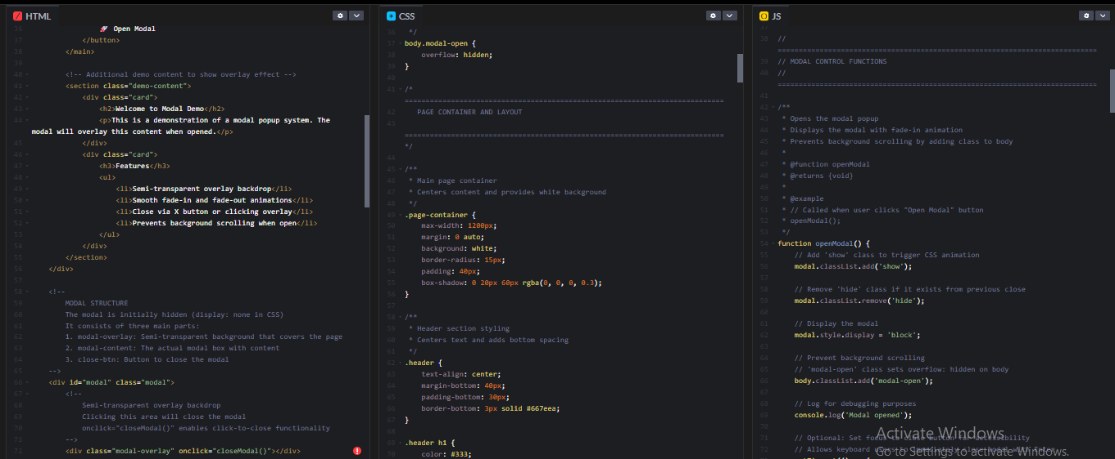
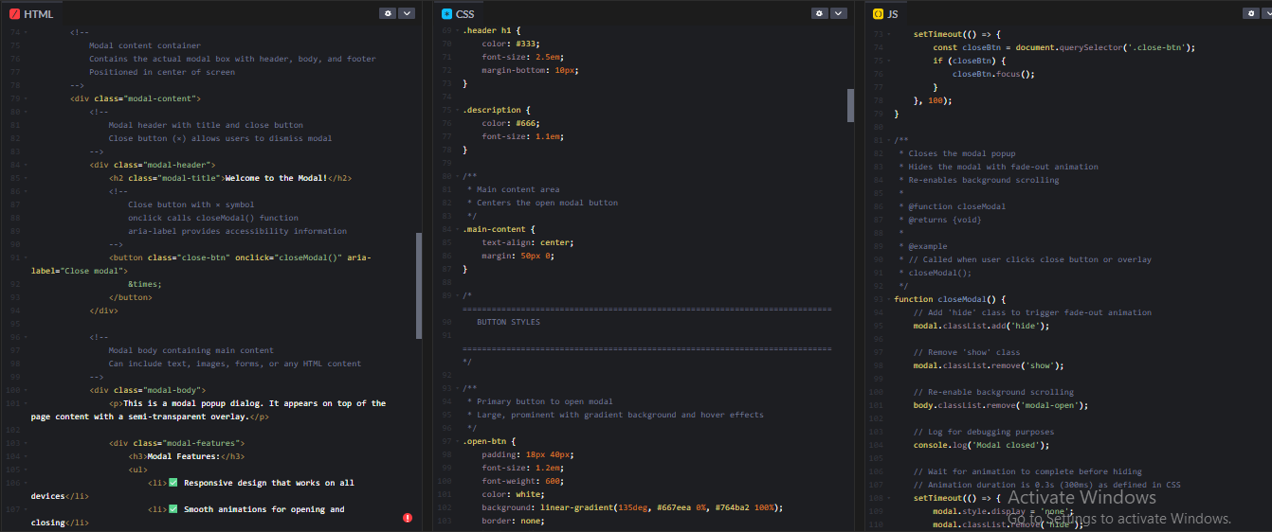
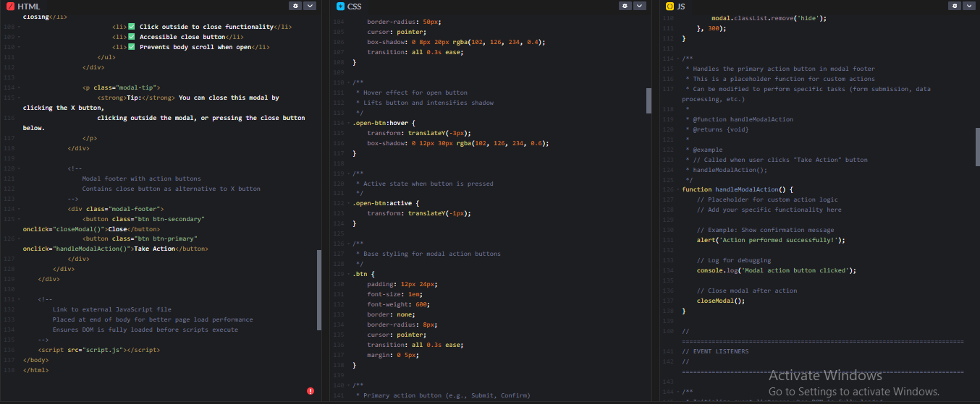
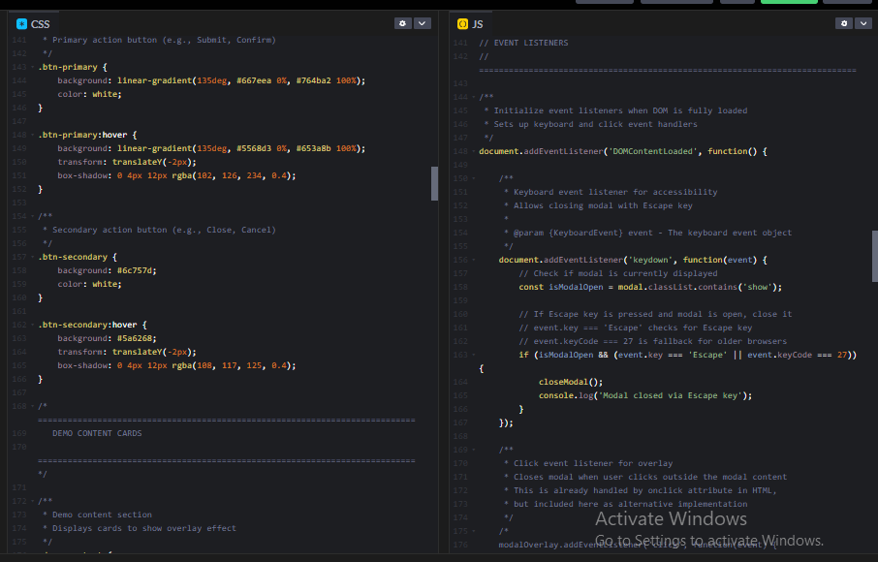
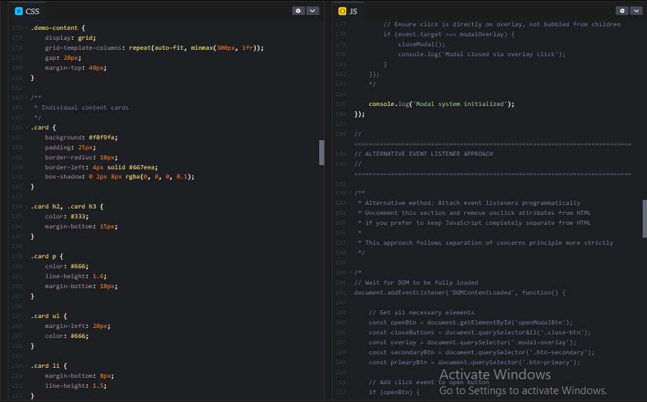
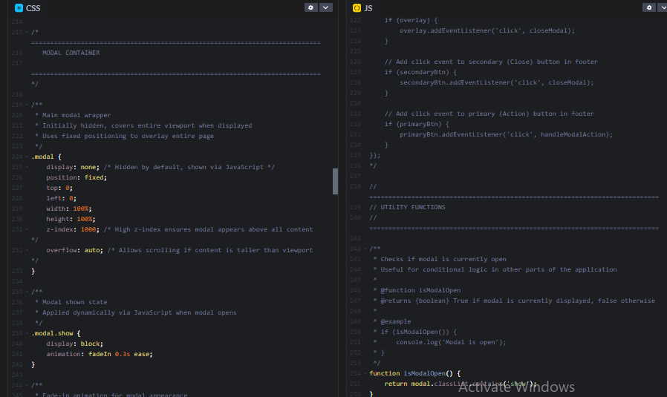
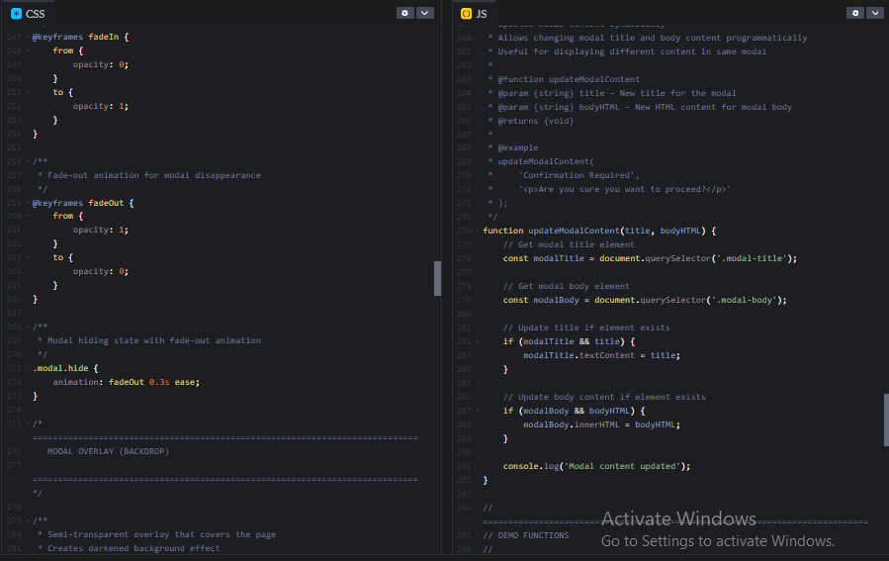
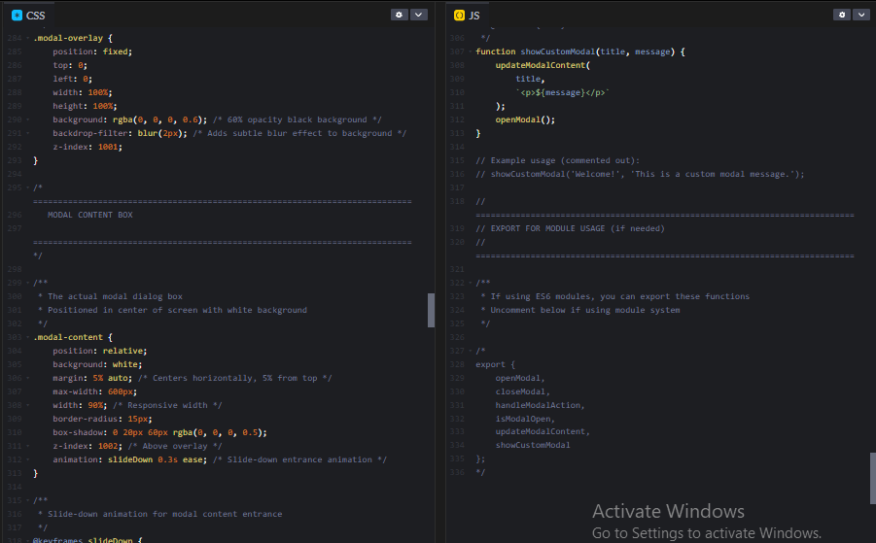
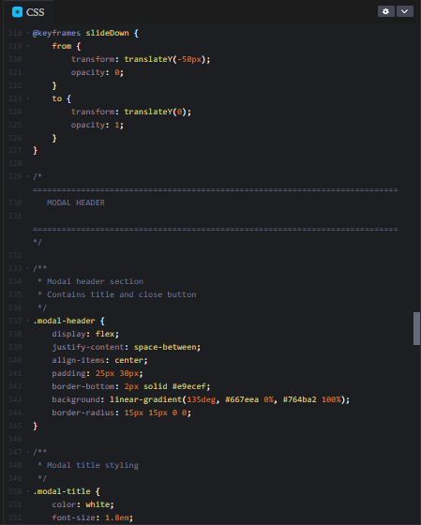
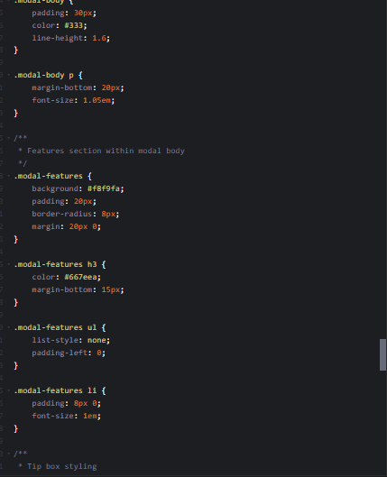
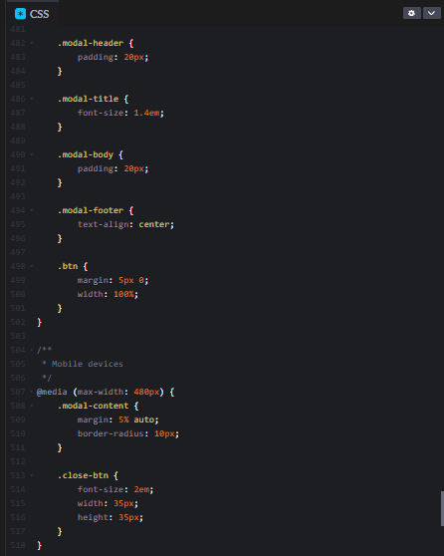
OUTPUT:
